

|  |
| --- |
| **[User experience and Design]** |
|  |
|  |
|  |





Table of Contents

Introduction: 3

The Strategy Plan 4

Product Objective 4

User 5

Data Gather: 5

Persona 6

Persona 7

Persona 9

Generic bank teller story 11

Specific bank teller story 11

Generic branch manager story 12

Specific branch manager story 13

Scope Plane 13

Scenario1: 14

Story board 15

Funds transfer: 15

Story board 16

Transition History 16

Story board 17

View Balance 17

Story board 18

Find nearby branch 18

Story board 19

Add Account 19

Bill payment 20

All Features 22

The Structure Plan 22

Sorting Cards 23

Navigation Structure 24

Skeleton Plan 24

Login Page: - 25

Sign Up Page 26

Profile page 27

Fund Transfer 28

Transition History 29

Contact us 29

Prototyping 30

Login 30

Sign Up 32

Home Page 32

Profile Page 33

Fund Transfer 34

Transaction History 34

Contact US 35

Conclusion and Recommendations 35

Usability 35

Accessibility 35

Reference 36

# Introduction:

The banking system builds on trust and integrity. Unfortunately, poorly designed websites or mobile apps can eliminate years of established credibility in seconds. People will not hesitate to click back, especially for ordinary people. On the other hand, the good news is that a positive first impression and improved user experience will increase user engagement on the site, which will ultimately lead to higher bank transfer rates. The banking system is changing over the Internet and becoming more customer focused. The Bank and its cooperative credit sites have the opportunity to attract online users and technological savvy with a more modern design. The web is designed to meet real user needs. There are many examples of creative web design that have fulfilled the unique requirements for their customers or users. From given scenario Mebak bank want to give an attractive login, balance check, transfer money between accounts, online statements, transaction history, setting up direct debits orders, contact the bank, finding the location of the nearest bank, manage multiple accounts and contact via email/phone services to its users. For that, the website needs an attractive web design to keep its users interested in its providing services. The banking environment is growing fast so it has to grow to keep its user intact who are from a different age, profession, and educational backgrounds as well. So, the system can run smoothly as the user want it to be. There are some simple points that should be followed while designing the web layout of the banking system. The basic banking terminologies should be simplified into user understandable language. There is always a goal that user want to achieve in minimum clicks. So, less number of clicks and more easy for the user. There some services that have a long procedure that should be divided into simple short procedures so that user can easily understand it without any confusion. The interface must be simple as possible and provide the main theme of the bank for a better understanding of the user. The images should be eye catching not much bright that disturb the user concentration.

So, there are three things that we have decided to keep in mind while UX designs. Firstly, it should be intuitive so that user can easily understand by using some common labels and images that user have seen before and have knowledge about them, that will allow the user to act consciously which is important for steady flow. Secondly, the web layout should also be consistent because it is important for the user not to get confused while in achieving a certain goal, each virtual thing should information that why it is there and what is its function. Thirdly the design must be responsive accordingly, e.g. mobile interface, PC interface.

# The Strategy Plan

Mekbak Bank wants to give many bsaic banking services to its customers. So, our goal is to create a better UX design for its website by using the concept of Human and user experience design. For such design, we have to know about our users that information is most important because it tells us what user want from Mebkat bank. Mostly importantly user wants to get things done as easily as possible. So, for that, we have to divide the long procedure into short steps or we can say goal into objectives and sub-objectives. Knowing your customers means you know what they expect from you. Gather all the data from your user via interview or something and make a proper list of requriements. In the requirement document, all features are clearly understandable. Know how you will use those features to make full strategy flow path. Carefully watch over the dependencies so nothing could go wrong in the flow path. Good graphics make a good impression, there will be a graphical representation of the concept that how the user will achieve his goal.

# Product Objective

From the given scenario we that the goal is to create a banking web application for mebak Bank. The customer of the bank can take benefits from many services that it is providing. The object here is to get those services as easily as possible by demonstrating it through UX designs. There are some certain technicalities that must be taken care off which are the following:

* The website should run on computer, mobile and Ipad so that the customer does not remain depandent on the hardware.
* The website should have an attractive and simple login page.
* There are a lot of people are using banking services all over the world. So, it must have the capability to full all their needs.
* Many customers may have more than one account. So, it should be able to manage more than one account at a time.
* It should have a link with other banks. So, the inter-bank transaction could be made.
* It should have the option where the customer can see his transaction history or check the balance.

# User

In this modern world, almost everyone is a bank customer. From research, it is shown that almost seven out of ten people are using the online banking system in the United Kingdom. But there is a wide range of customer who differs in age, education, and profession. For a better understanding of the user there will be survey and interviews. The data from the user will be gathered and arranged accordingly. It is important to take care of requirements gathered from the user because that is what they want and it is all about the user.

# Data Gather:

As mentioned above, the data is collected from interviews and survey taken from the user. The real user can better tell us what problem they face while using banking services and what are they expecting from the bank as a solution to their problem.

1. ***Bank Teller***

How would you convince a customer to become a client of this bank?

How do you face the pressure?

What are your weaknesses?

What are your strengths?

What do you feel is the most important asset a bank teller must have?

How stressful is your job?

What tasks are involved to achieve your goals?

What activities take up most time?

What problems do you encounter while working?

What are the most enjoyable parts in your job? What do you value most?

***B. Branch Manager***

How much training is required to complete the task?

What are you responsible for in your job?

In what do you think a centralised system would benefit you?

What makes you loose trust on a system?

What activities take up must time?

How much time is required to complete the task? How to you think it could decrease the amount?

Beside clients / customers, whom else do you interact with while doing your work? Who do you report to? Who reports to you?

Describe a typical workday?

How is your office organized to help you accomplish your tasks/goals?

Is there anything missing that would make you daily work easier ?

***C. Branch Manager***

What is the most frustrating part of your business?

How often do you interact with the system every day?

Want to fill in the online registration forum?

Which online services do you use most often?

What is the difficult or frequent use of online services?

What online banking service are you using?

What devices do you want to use for online banking?

Are you using online banking?

How often do you log in to the site?

# Persona

|  |  |
| --- | --- |
| *Eva-Bank Teller* | |
| A person sitting at a desk  Description generated with very high confidence | *A black sign with white text  Description generated with very high confidencePersonal Information:* |
| * She is 26 years old. * Eva lives in London but is born in Greece. * He likes to be a communicative and friendly person. * During her free time she watched the TV series. |
| A close up of a logo  Description generated with very high confidence Technical experience: | A close up of a logo  Description generated with very high confidenceValues and fears: |
| * Eva has knowledge in excel, word, power point and data base. * Always try to advance and learn more. * Her best acquaintance is communicating with clients. | * He's afraid of failures. * He knows how to talk to people. * He is an open and intelligent person. |
| A close up of a logo  Description generated with very high confidenceResponsibilities: | A picture containing outdoor, electronics  Description generated with high confidenceGoals: |
| * It needs provide all the customer support and make them available. * Open new accounts. * Resolve issues and problems with customer’s accounts. * Process cash withdrawals. * Order bank cards and checks for customers. | * Create a new booking for a customer. * Solve card problems. * Maintains customer confidence and protects bank operations by keeping information confidential. |

# Persona

|  |  |
| --- | --- |
| *Jack- Branch Manager* | |
| A person sitting at a desk  Description generated with very high confidence | *A black sign with white text  Description generated with very high confidencePersonal Information:* |
| * He is 41 years old. * Jack lives in London but is born in India. * He likes to be a communicative and friendly person. * During his free time he pay a lot of games. |
| A close up of a logo  Description generated with very high confidenceTechnical experience: | A close up of a logo  Description generated with very high confidenceValues and fears: |
| * Jack has knowledge in excel, word, power point and data base. * Always try to advance and learn more. * His best acquaintance is communicating with clients. * It does well under pressure. | * He's afraid of failures. * He knows how to talk to people. * He is an open and intelligent person. * He's afraid of snakes. |
| A close up of a logo  Description generated with very high confidenceResponsibilities: | A picture containing outdoor, electronics  Description generated with high confidenceGoals: |
| * Understand bank products and respond appropriately to customer inquiries regarding products; refer to CSR as appropriate. * Accept assignments as required to maintain adequate staffing levels throughout branch system. * To provide friendly and professional customer service while processing customer transactions accurately and efficiently. | * He is responsible for the failure of his colleges and he need to correct the mistake. Solve card problems. * Maintains customer confidence and protects bank operations by keeping information confidential. * Accurately process deposits, withdrawals and payments |

# Persona

|  |  |
| --- | --- |
| Adam Bank Marketing | |
|  | *A black sign with white text  Description generated with very high confidencePersonal Information:* |
| * He is 25 years old. * Adam lives in London * He is married. * During his free time he watch news. |
| A close up of a logo  Description generated with very high confidenceTechnical experience: | A close up of a logo  Description generated with very high confidenceValues and fears: |
| Communicating with Public relation professionals   * Marketing skills. * Always try to advance and learn more. * His best acquaintance is communicating with clients. * Managing Social Media * It does well under pressure. | * He's afraid of failures. * He knows how to talk to people. * He is an open and intelligent person. * He's afraid of snakes. |
| A close up of a logo  Description generated with very high confidenceResponsibilities: | A picture containing outdoor, electronics  Description generated with high confidenceGoals: |
| .   * Develop cross-channel marketing programs for the Wholesale Banking division that elevate the organization’s brand reputation and creates increased demand for support and services within the middle-market and debt capital market * Partner with brand and product teams to create effective go-to-market strategies for new and existing products. * Passionately promote the Bank brand promise and messages throughout the company to help foster a culture of living and owning the brand message | * Comfortable working with Senior Leadership in championing new approaches, securing incremental budget allocations and gaining buy-in and support for unique and unfamiliar marketing tactics and techniques. * Experienced in conceptual development of product promotions and brand campaigns, with a proven track record of effectively managing vendors to deliver on time and within budget. |

## Generic bank teller story

## Specific bank teller story

A picture containing sky

Description generated with very high confidence

## A close up of a device Description generated with high confidenceGeneric branch manager story

## Specific branch manager story

A close up of a sign

Description generated with high confidence

# Scope Plane

Online banking System provides banking services to the user where they can access all banking services. As the data is gathered from the user and from the bank as well to clarify the requirements that what the system will do? Who will be the user and what is the purpose of the system? we have Identified that the goal of the system is to give a user a platform where it is easy for him to use banking services, Account management in just a few clicks. The goal consist of the following objectives:

* The users can manage Multiple Accounts if they have more than one account.
* The user can log in to their Accounts by providing the credential right.
* The user can transfer money to similar Bank Account and another bank Account as well as international Account
* Usesr can transfer money to their master Card.
* Users can pay Bills through their account.
* Users can see History of Transactions of their accounts.
* Users can Contact Bank through feedback or live chat in case they have a problem.
* Users can search for a nearby branch from Their current location using map service.
* Users will be able to contact the bank through their email and phone.

## Scenario1:

In this scenario, the online banking system will provide the Sign up/ Login feature to its user. The customer has to perform some function in order to get successfully login/sign up. The function that a user must perform is written below.

When the user is already Sign up and want to perform Login functions:

* Click on the login button from the home page of banking website.
* Enter the username and password.
* Then click on the login button.
* The website will display the user dashboard

When the user is not signed up before:

* Click on the sign-up button from the homepage.
* Input all required data accurately.
* Click on sign up button.
* Validate the input information.
* Fill the value to login
* The website will display a user dashboard.

## Story board

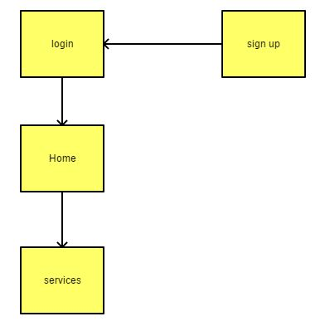

## Funds transfer:

In this scenario, the user wants to transfer funds to other accounts using online services provided by the bank. The user will enter the details of the receiver and amount that the user wants to send will follow will be:-

* The user must log in first with correct credentials.
* The user will select the fund transfer option from the user dashboard.
* The user will Select Account transfer which is going to be transferred.
* The user will Select the type of transfer.
* The user will provide the detail of the receiver.
* The user will Select the amount of money that is going to be transferred.
* Then click on the transfer funds.

## 

## Story board

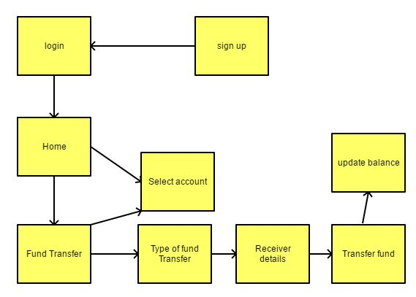

## Transition History

In this scenario the User want to check transaction history of his account. The user must be already login to his account.

* The user selects the Transaction history option from the dashboard.
* The user will be provided the transaction history of his account.
* The user can also select a transaction from the specific date/time.
* The system shows the table of the transaction from a specific time period.

## Story board

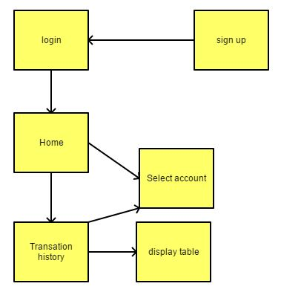

### 

## View Balance

In this scenario, the User wants to check the Current balance of the Account.

* The user has signed in already with correct confidential.
* The user clicks on the view balance Option from the user dashboard.
* The user specifies the account detail.
* The system displays the current balance of the account to the user.
* Story board.

## Story board

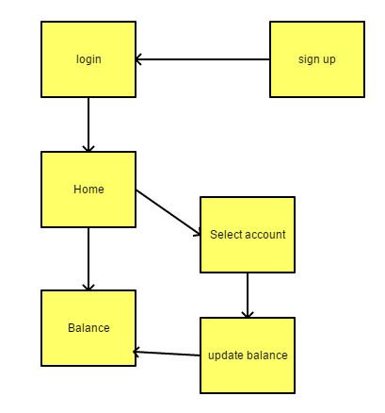

## Find nearby branch

In this scenario, the user wants to find out the nearby branch from their current location.

* The user has logged in already with correct confidential.
* The User Request to find nearby bank branches from his location.
* Maps service display the map to the nearby branches.

## Story board

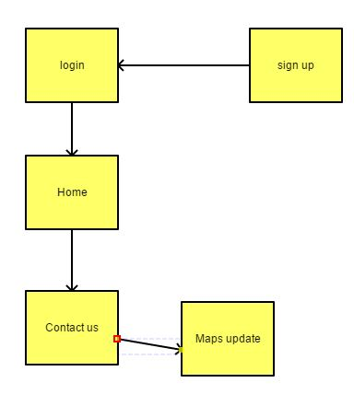

## Add Account

In this scenario, the User wants to Add new Account.

* The user has logged in already with correct confidential.
* The user clicks on add account option.
* The user fills the form of add account fields.
* The user specifies the type of account.
* The user clicks on the save button to create a new account.

Story board

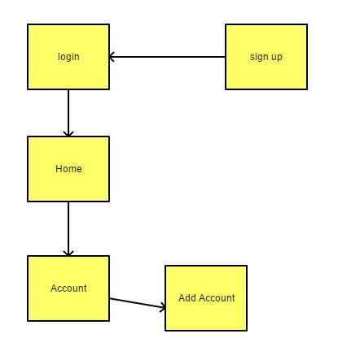

## Bill payment

User want to Add new Account.

* User must Login
* User add the Account
* Fill the account authentic details
* Select the type of account
* Save the new Account

Story Board

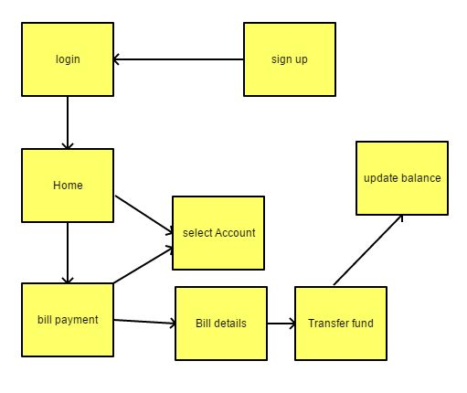

# All Features

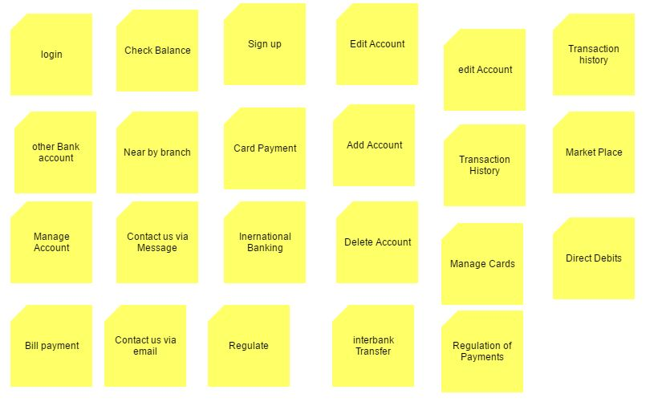

# The Structure Plan

In this scenario the navigational structure of the online banking system which is connected in manners according to their priority.

* The User can have Multiple Accounts.
* The user will sign up to a banking account.
* The user must be logged in with correct confidential in order to make use of banking services.
* The user can transfer money to similar Bank Account, another bank Account and into international Account
* The user can send money to its master card from account.
* The user can pay bills from his account.
* The user can see the transaction history table.
* The user can see Deposit and Cashed statements from the dashboard.
* The user can make Contact Bank through feedback/live chat
* The user can search the nearby branch location branch from Their current location through Map services
* The User can make contact bank through email/phone.

# **Sorting Cards**

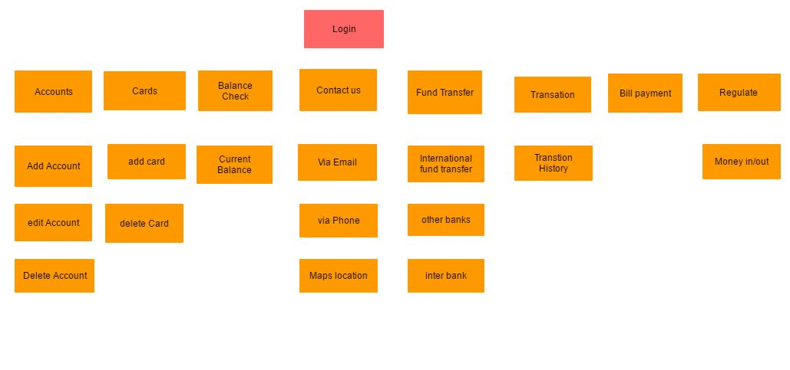

# Navigation Structure

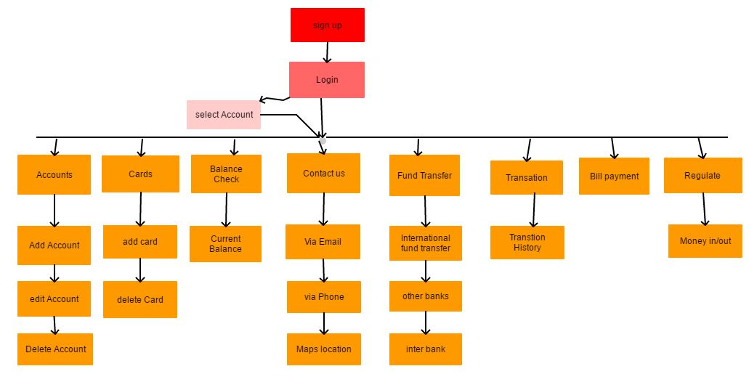

# Skeleton Plan

Landing Page

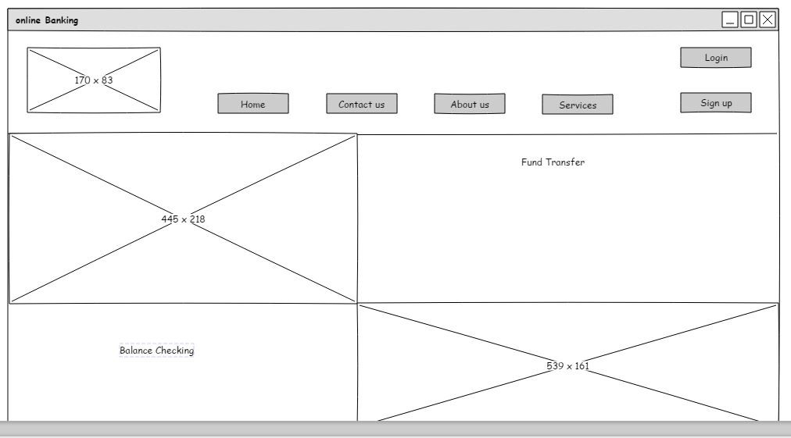

* The logo represents the shortcut to the homepage.
* There are two buttons of the sign in and log in.
* The bank services are described in the list.
* The image describes the specific details
* The image describes the service.
* A short note about the services.

## Login Page: -

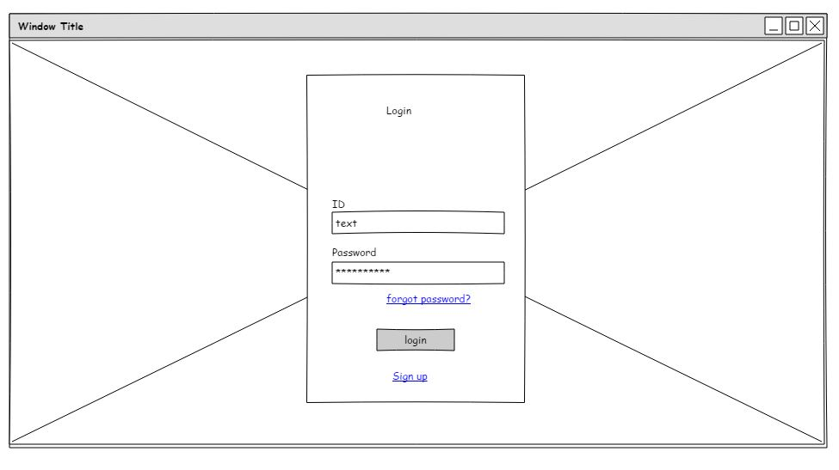

* Log in page
* Text fields about the username and password
* Button for login and sign up
* Small button services nearby branchs

## Sign Up Page

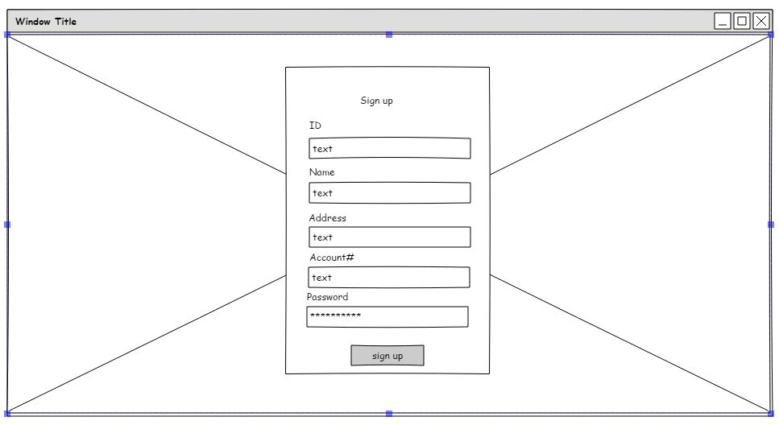

* There is logo of bank.
* Username field
* Mobile number field
* Email number field
* Exit button
* Login button.

## Profile page

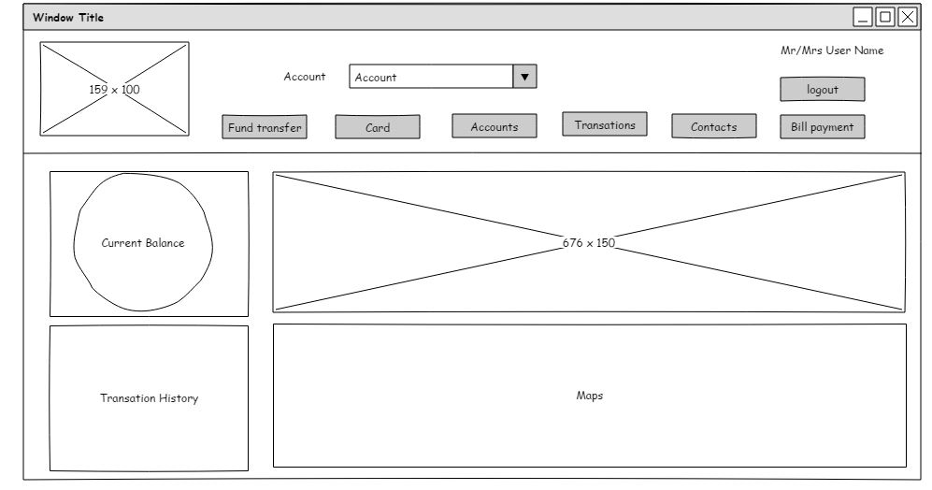

* Bank logo
* Showing the balance status.
* Showing balance in digits.
* fund transfer button
* debit card option
* accounts specification option

## Fund Transfer

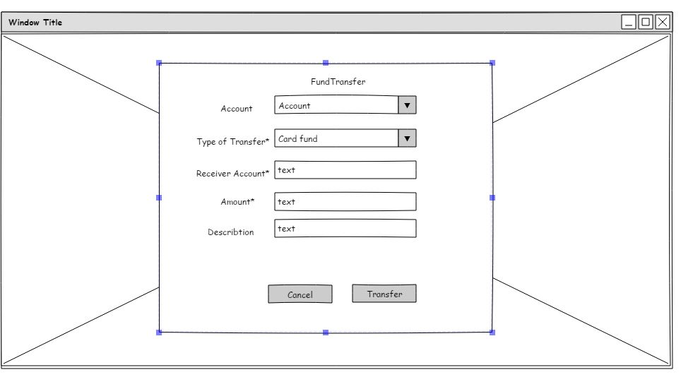

* Exist account option
* Add new Account
* Add international Account
* Receiver Details option
* Amount details option
* Exit button
* Transfer balance specified.

## Transition History

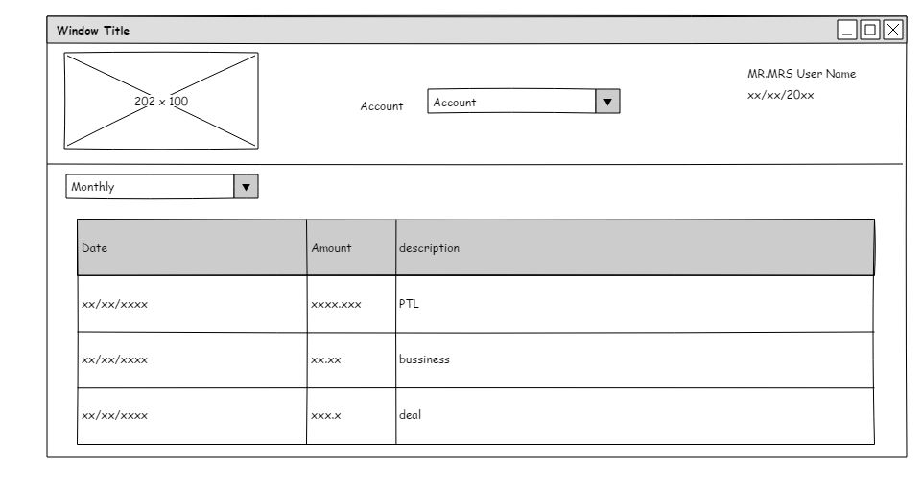

* Set the date details about the display
* Currency values amount
* Opening balance amount
* Closing balance amount
* transaction details

## Contact us

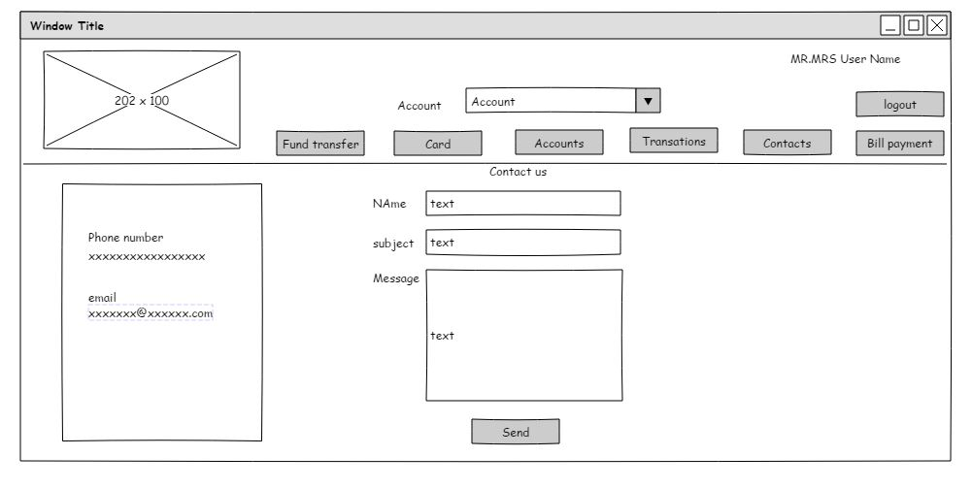

* Title display
* Email display
* Text display
* Chat Live menu

# Prototyping

## Login

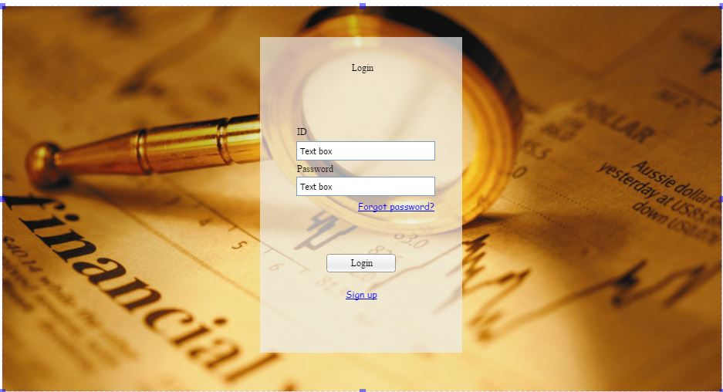

## Sign Up

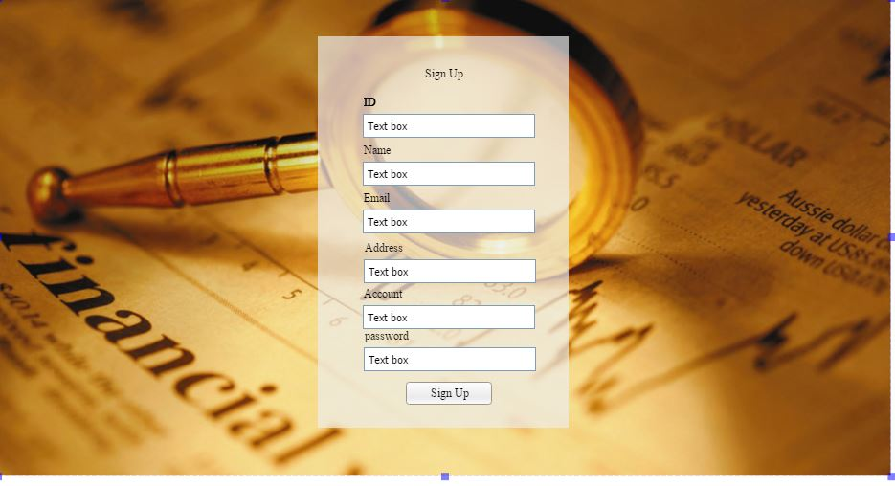

## Home Page

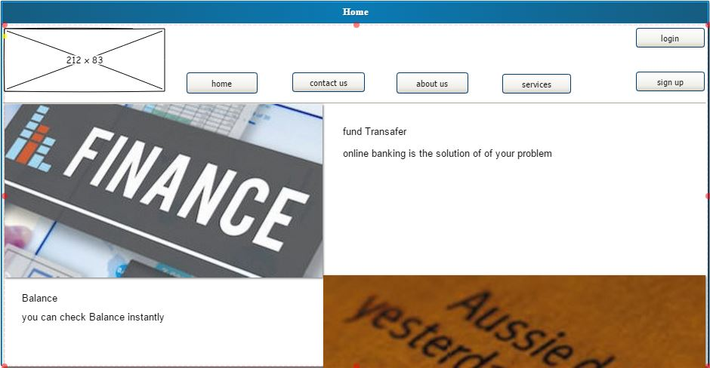

## Profile Page

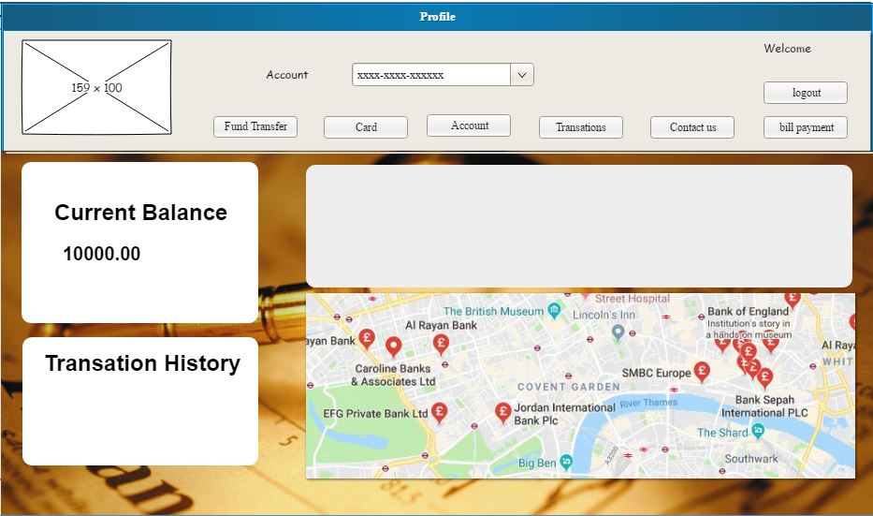

## Fund Transfer

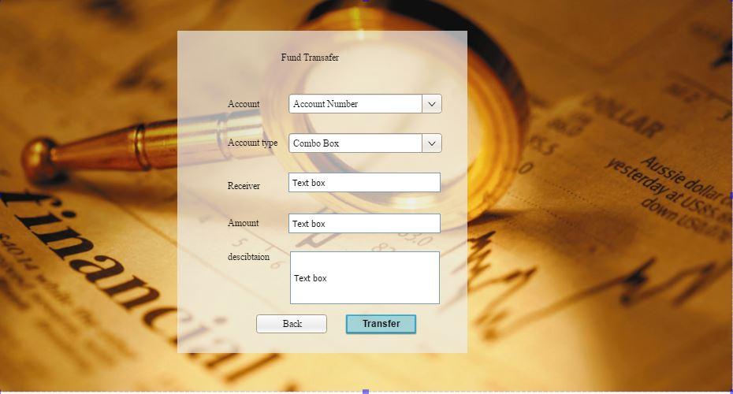

## Transaction History

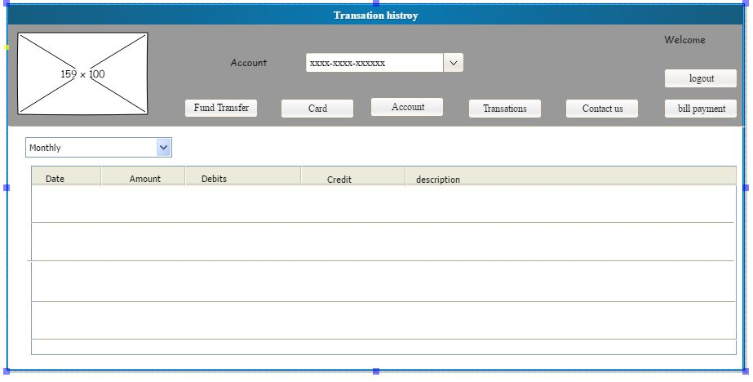

## Contact US

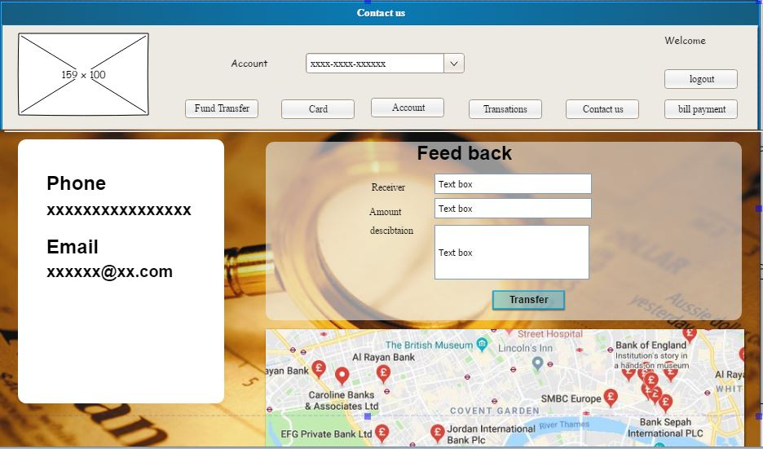

# Conclusion and Recommendations

As far as we know, it is easy to understand how to improve work efficiency. Users are not nervous about understanding the website interface, then it is easy to use. If users are finding it easy to use, then they will use online banking.

## Usability

* Create a simple web interface to help users to learn.
* The text color is black and the background is white and gray. Text size in front between 12 and 18 for enhanced visibility
* The return of white and gray backlight helps to focus on the main content
* Blue is used for service links.
* Consumers should be satisfied, and it is possible that the design is effective, effective and easy to learn.

## Accessibility

* A simple structure is that does not lose the actual content to create easy-to-understand content so that the user can achieve his goals.
* The prompt tools are used for addresses and options to reflect the purpose of the service.
* Follow the same structure and appropriate address to prevent users from time wasting.
* Shared services are used at specific locations at the top of the site.
* All platforms are running this service like iPads, mobile devices, and computer devices.